

Overview

The caCORE Workbench is an integrated platform that allows users to generate a caBIG® silver or gold compliant system from a simple GUI. Using this workbench, the user can create a new data service application by specifying the UML model and the system generation settings. The Workbench saves time and reduces human error in generating a semantically integrated “caCORE-like” system.

caCORE Workbench – Application Development Environment

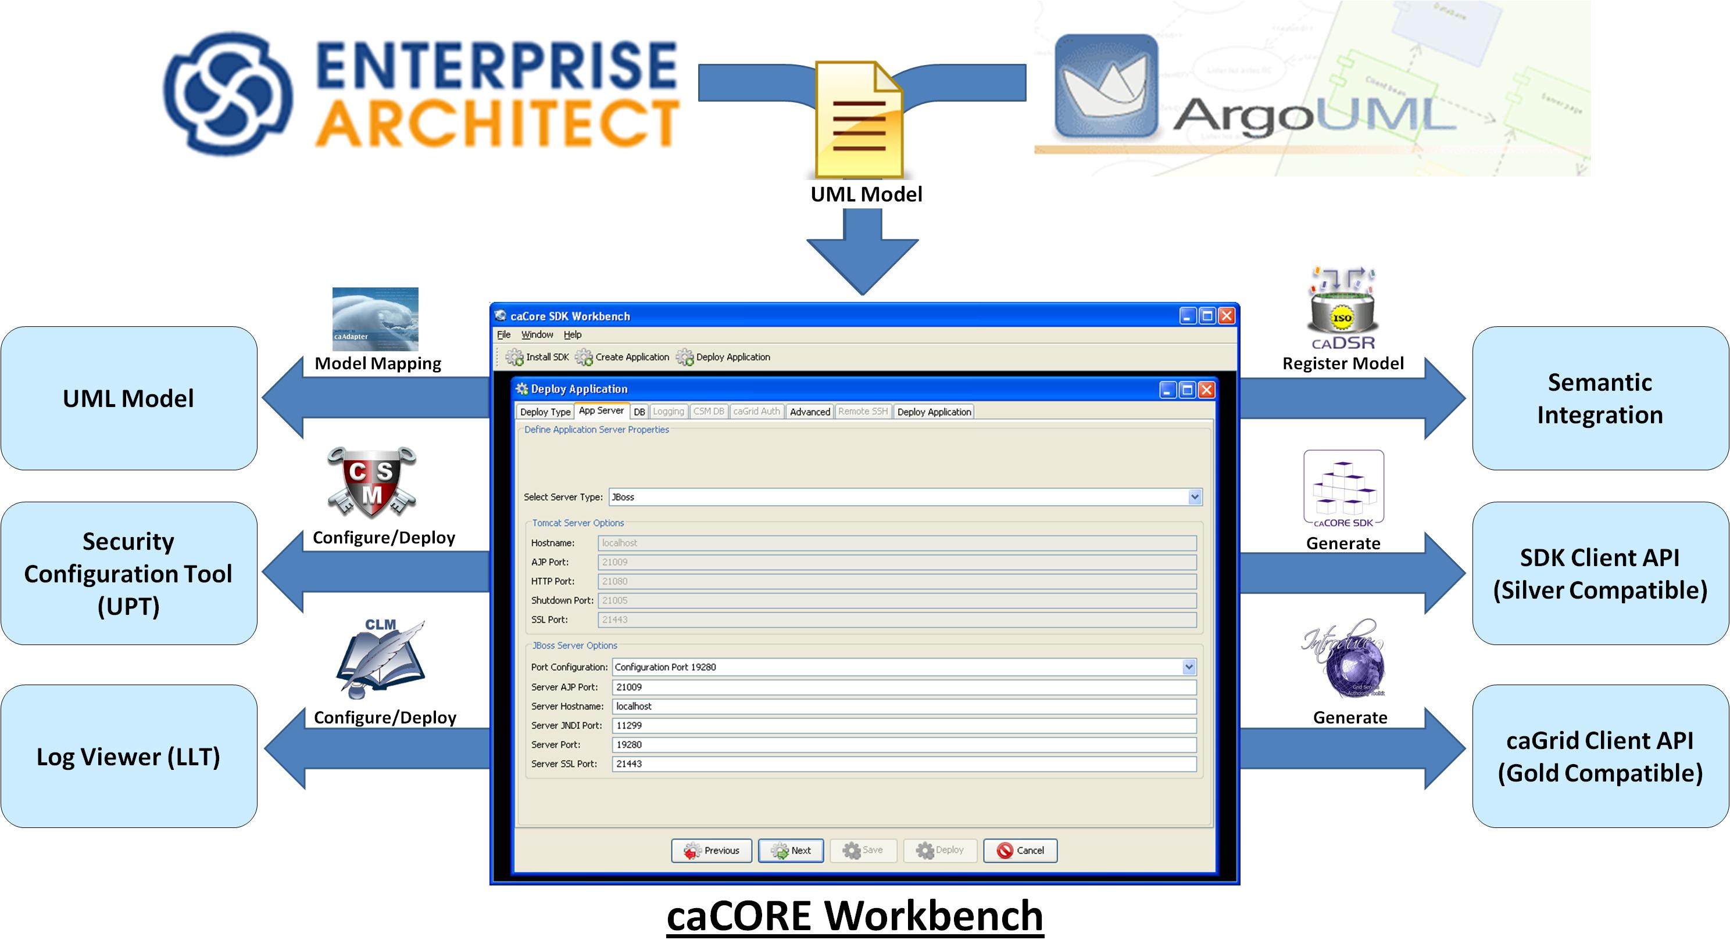

Benefits of caCORE Workbench

- Reduces the learning curve for the individual tools and workflows between the tools
- Provides a single tool to manage all the steps to create an application
- Enhances the user experience and encourages participation from the user community in the caBIG® program
- Allows rapid evaluation of tools and technologies offered in the caBIG® program
- Improves productivity of the developers by reducing the development cycle and the cost

Implementation Plan

- Phase I: In progress
  - Establish the foundation of the workbench
  - Enable individual tools to use the workbench and implement their workflow
- Phase II: Future
  - Integrate existing tools and their workflows in the workbench
  - Maintain boundaries between individual tools in the workbench
  - Implement additional workflows to manage the application development process
- Phase III: Future
  - Harmonize the workflows between the individual tools
  - Eliminate boundaries between the tools to provide an unified view

Continued on page 2
Current caCORE Development Process

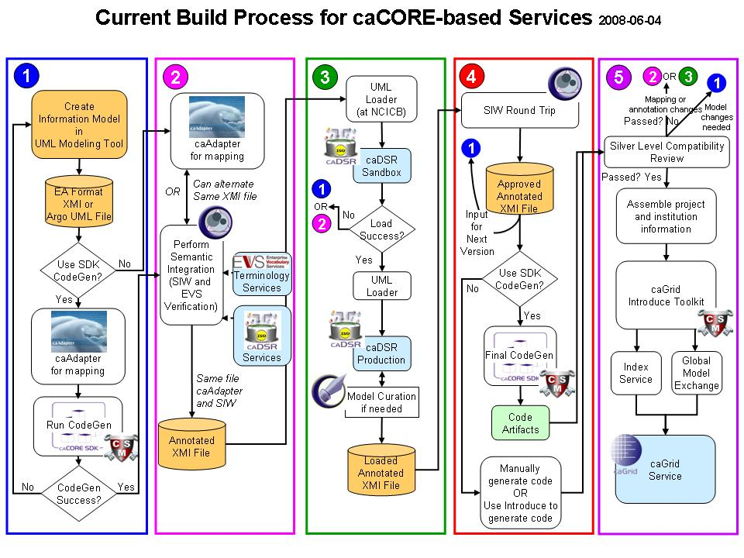
Limitations of the Curent caCORE Development Process

- Steep learning curve for the process in addition to the individual tools
- An array of tools to generate a single application in the caBIG® program
- A set of documentation needed to be studied to learn application development process
- Errors encountered in the later stages of the process requires repetition of prior stages

Important Links

caCORE SDK: https://cabig.nci.nih.gov/tools/caCORE_SDK
GForge: https://gforge.nci.nih.gov/projects/cacoresdk/
Mailing List: CACORE_SDK_USERS-l@list.nih.gov

